|  |
| --- |
| **CASE MANAGEMENT SYSTEM DEVELOPMENT WORKSHOP REPORT**  **THE DIRECTORATE OF ICT** |
|  |
|  |

**THE JUDICIARY**



9/03/2017

Case Management System Development Workshop Report

1 Introduction 3

2 Objectives of the Workshop 3

3 The workshop outputs; 4

4 Scope of the Developed Prototype 4

5 Global Picture of the Case Management System 4

6 Analysis of Developed CMS Modules 5

7 System User Management 5

8 Login page Screen Shot 6

9 The dashboard screenshot/Home Page 8

10 USER MANAGEMENT DASHBOARD 9

11 Case Registration Module 12

12 Case Activities/e –diary 14

13 Case Activities Dashboard 15

14 E-Filling 16

15 E-filing portal Screenshot 17

16 File Movement tracking 18

17 CMS File Tracking Screenshot 19

18 Court fees management 20

19 Court fees module screenshot 21

20 Reporting portal 22

21 Reports Portal Module Screenshot 23

22 Database Schema Design 24

23 Technical Team 25

24 ANNEXURES: COURT CASE PROCESS WORK FLOW 25

# Introduction

The Judiciary Transformation Framework (JTF) identifies ICT as an enabler to Justice while the Judiciary Strategic Plan (2014-2018) acknowledges that "Information and Communication Technology (ICT) has enormous potential to provide a quantum leap in the administration of justice as a cross-cutting imperative for all the pillars of transformation". Additionally, it points out that "propery harnessed and deployed ICT systems will augment efficiency and effectiveness of both back office and court processes facilitating expeditious delivery of justice.

The Judiciary Strategic Plan 2014-2018 identifies key strategic issues namely; Access to Justice, Progressive Jurisprudence, Organizational Development, Operational efficiency, Facilities development , Management and Governance. The strategic issues are further cascaded into key result areas most of which rely heavily on ICT for their achievement. The strategic plan puts mainstreaming ICT‟s at the center of Judiciary organizational change and improvement of service delivery and operational efficiency.

# Objectives of the Workshop

The workshop had only three (3) objectives as outlined below

* To conceptualize the SRS and do process mapping of the workflows in the SRS into a Case Management system for the entire court Ranks
* To Design and Develop a complete Case Management System for all court Ranks
* To Design & Develop the Database for Court management systems

# The workshop outputs;

* Complete prototype of Case Management System
* Complete Database for Case Management System

# Scope of the Developed Prototype

The case Management System archetype Developed had the following modules:

* System User Management
* Case Registration
* Case empaneling Calendaring (e-Diary)/Case Activities
* E-Filling
* File Movement tracking
* Court fees management
* Reporting portal

# Global Picture of the Case Management System

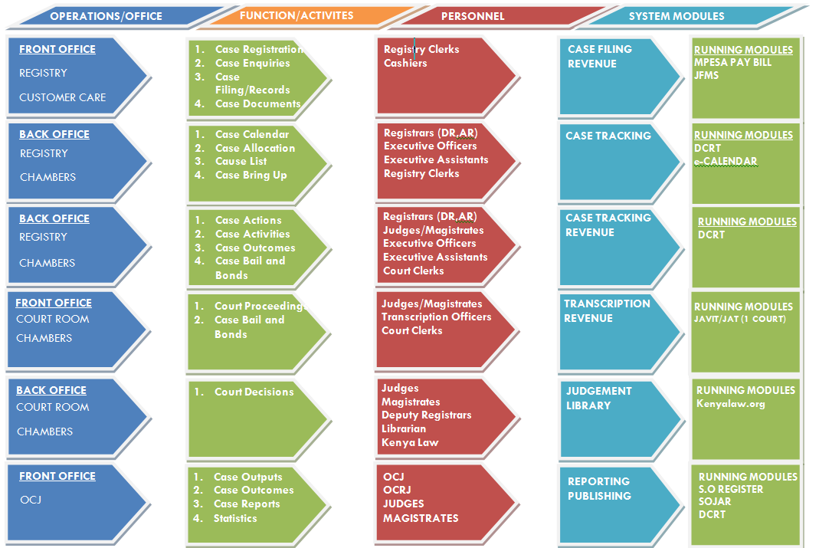

# Analysis of Developed CMS Modules

# System User Management

This is the foundational module for the system it manages how users access the system and what permission levels /privileges they posses

We adopted Role based user management approach as illustrated below

* + - User Class 1- Registry Users (Court Assistants, E.O)
    - User Class 2 – Judicial Administrators (DR, HOS, Presiding Judge, Principal Judge)
    - User Class 3 – Judicial Officers (Judges, Magistrates)
    - User Class 4 – ICT Administrators (ICTO, ICT Director)

# Login page Screen Shot

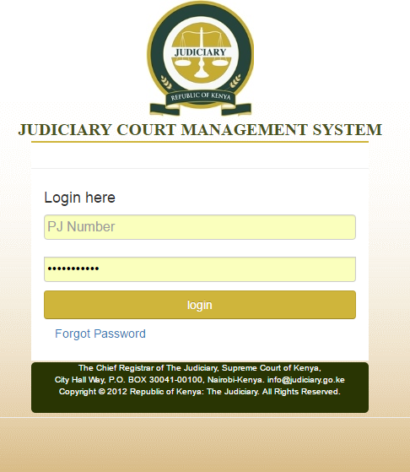

To Minimize User Support related issues and also has a best practice users are able to reset their passwords via the official Judiciary e-mail

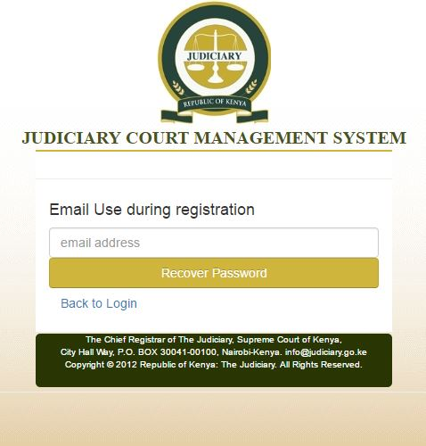

# The dashboard screenshot/Home Page

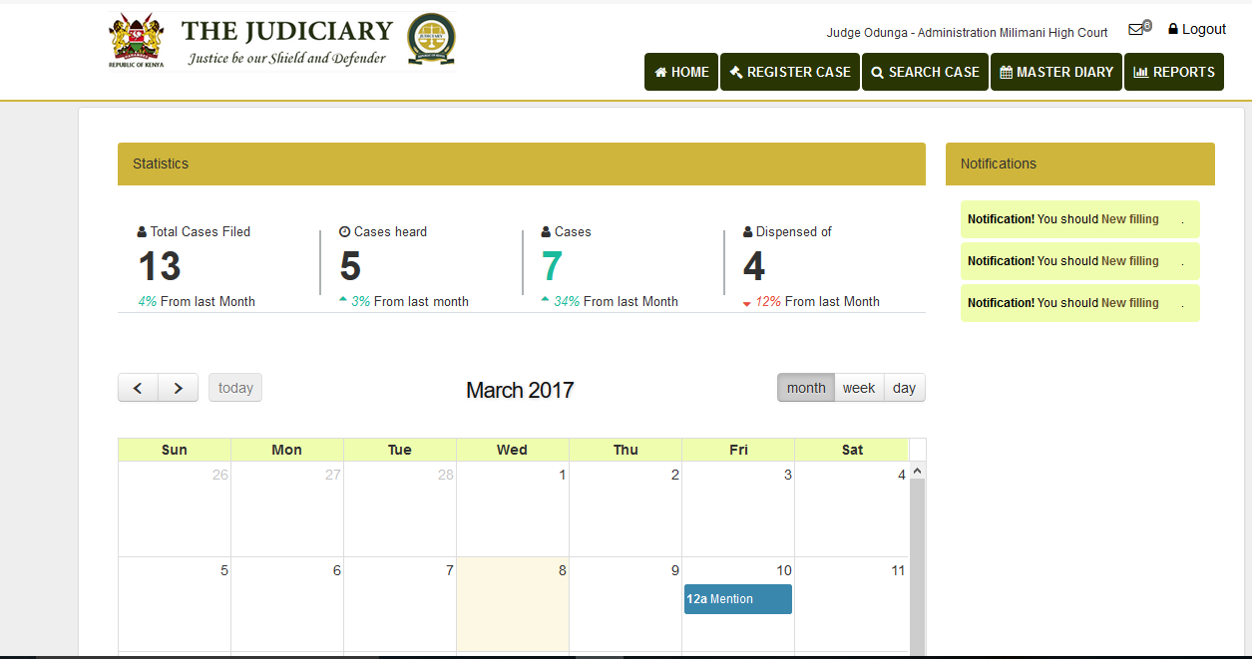Dashboard is customized for the user logged in and shows the following

1. Notifications to logged in user (items requiring user attantion)
2. Case statistics/Performance statistics for the user
3. The electronic Diary
4. Reports portal (authorized reports only)

# USER MANAGEMENT DASHBOARD

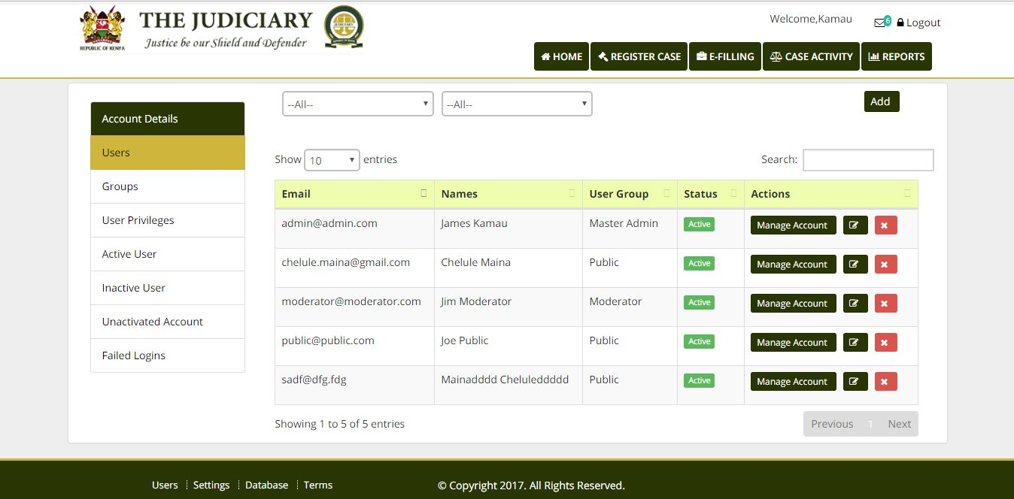

**Creating a New User**

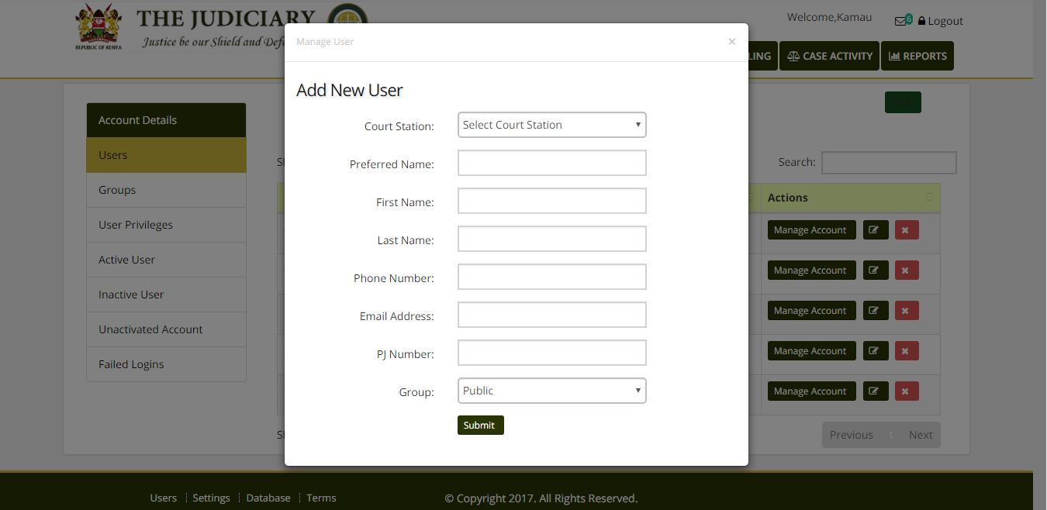

#### **Updating the Details of the Existing user**

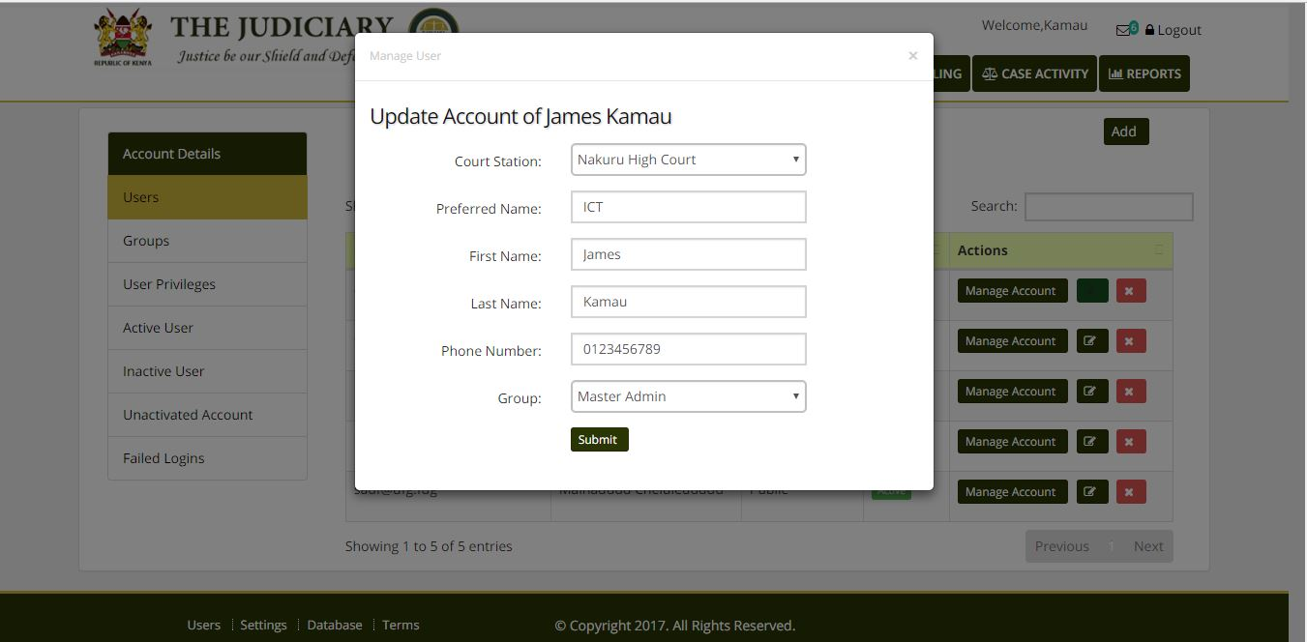

**Managing User permissions and Privileges**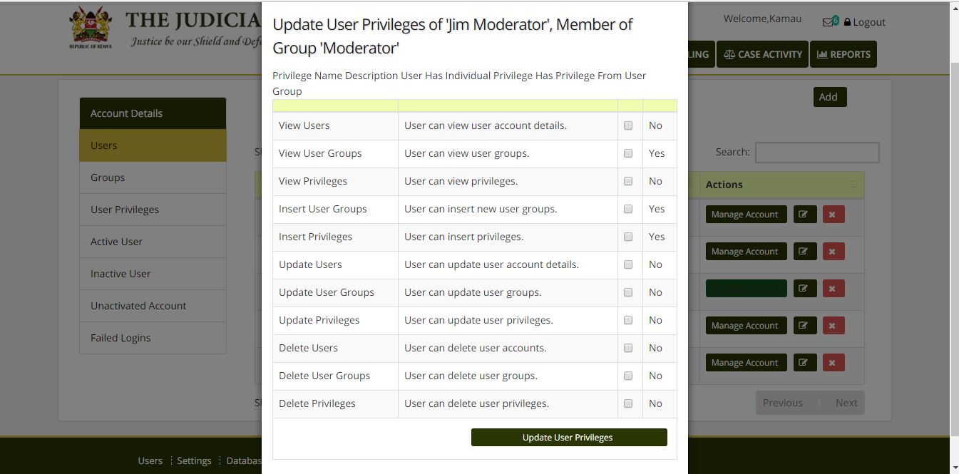

#### **Suspending a user Account**

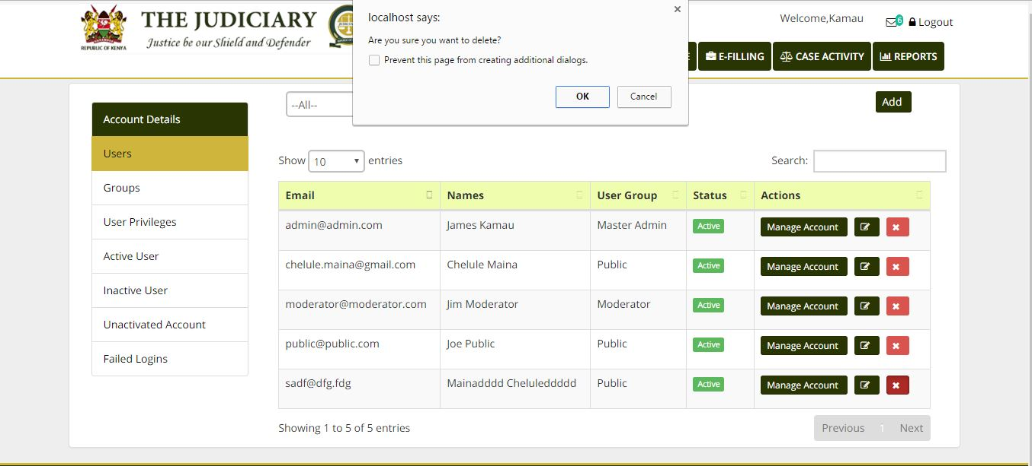

# Case Registration Module

Case registration deals with introduction of the case into the CMS

**Attributes of Case Registration Entity**

**Case registration**

Case Number

Case Code

Law Firms

Court station

Case Type

Appeal Case Number

Case Status

Date of Filling

Parties Info

**Registering a case screenshot**

Case type: Commercial

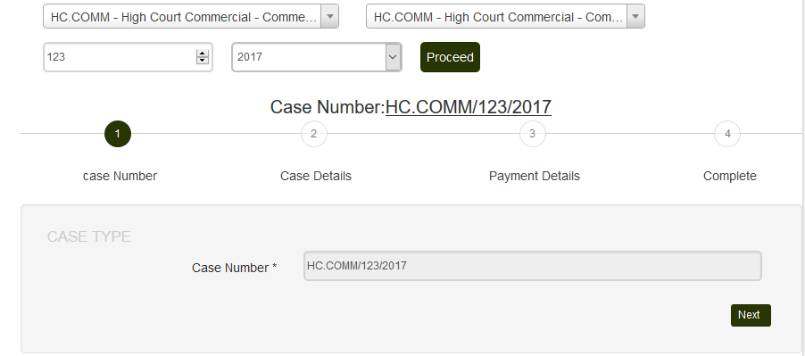

**Registering an Appeal**

**Case Type: Criminal Appeal Reg.**

N/B the Case registration form is customized for each specific case Requirement

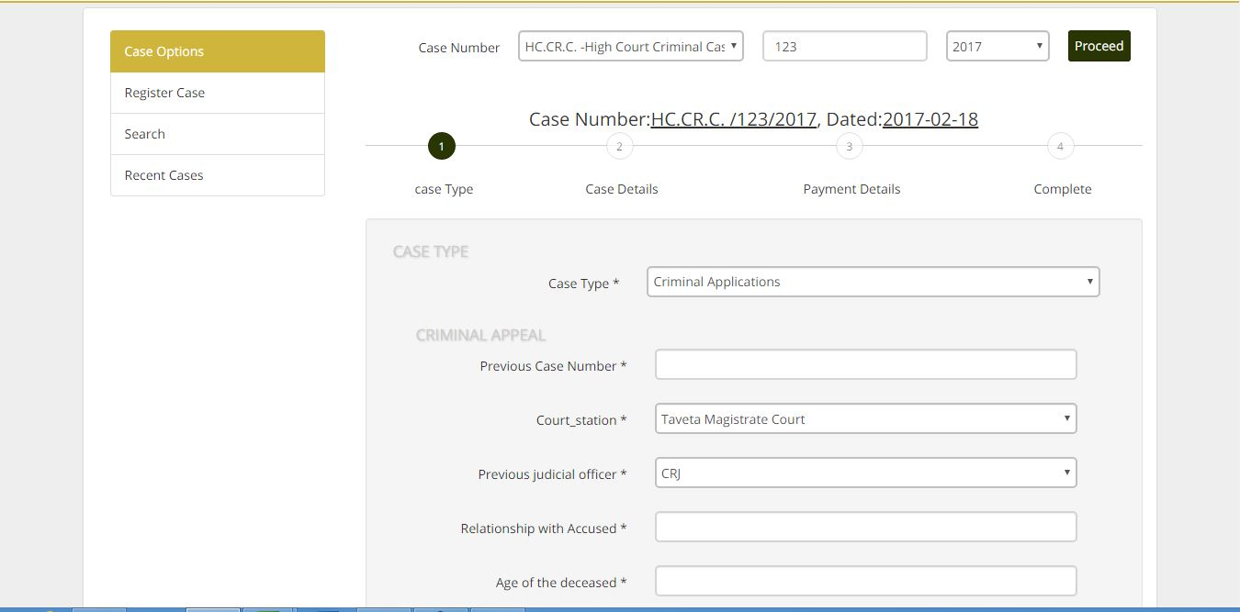

# Case Activities/e –diary

The e-diary entails assigning of a case date and case activity to a judicial officer or a bench

**Attributes of E-Diary Entity**

**E-DIARY**

**Date allocation**

**Taking out matters**

**Case transfer**

**Mailing Causelist**

**Generate Causelist**

**Caseload statistics**

es Info

**Judicial officer**

# Case Activities Dashboard

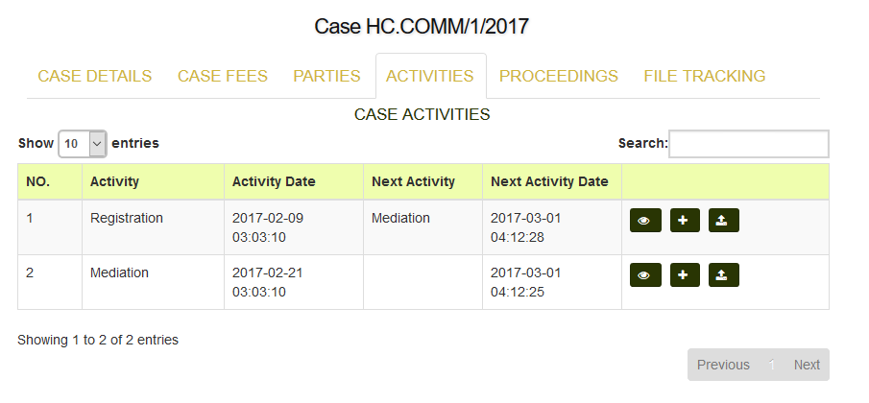

Electronic Calendar



# E-Filling

The module should be responsible of electronic filling, storage and documentation of case proceeding.

The following is the list of examples of documents to be electronically filed.

**Attributes of Electronic Filing**

Document Owner

Document Name

Document Category

Court Evidence

Case Initiation Documents

Appearance notices

Description

Security Documents

Complaint Replies

Court Proceedings/Summons

Exhibit Photos

**Documents**

Files to be uploaded are linked to a specific case and a specific party or a specific advocate in record.

The file should contain the name of the file, the category which the file is filed under, and the detailed description of the file

# E-filing portal Screenshot

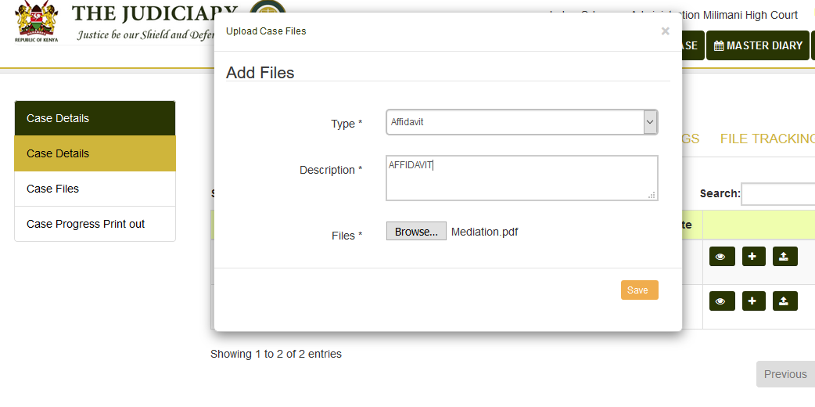

# File Movement tracking

This module assists in tracking and logging of physical movement of case file within the court premises. File tracking minimize misplacement of files & ensure accountability in handling of files

**Attribute of File Transfer and Tracking Entity**

**File Transfer and Tracking**

File Location

File Destination

Movement Reason

Current Date

Action Officer Name

Officer Taking Files

# CMS File Tracking Screenshot

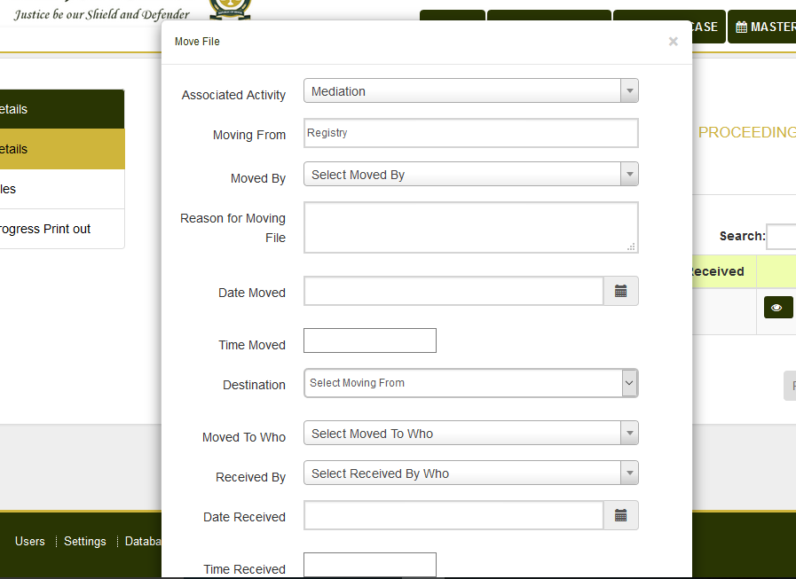

# Court fees management

The module provides mechanism of recording of all monetary transactions within a case.

The module facilitates the manual and electronic payments and return of bonds and bails.

The module also facilitates both manual and electronic invoicing and payment of court charges and fines

**Attributes of Court Fees Entity**

**Court Fees**

Payment Type

Payment Method

Amount Assesed

Amount paid

Date

Payer Name

# Court fees module screenshot

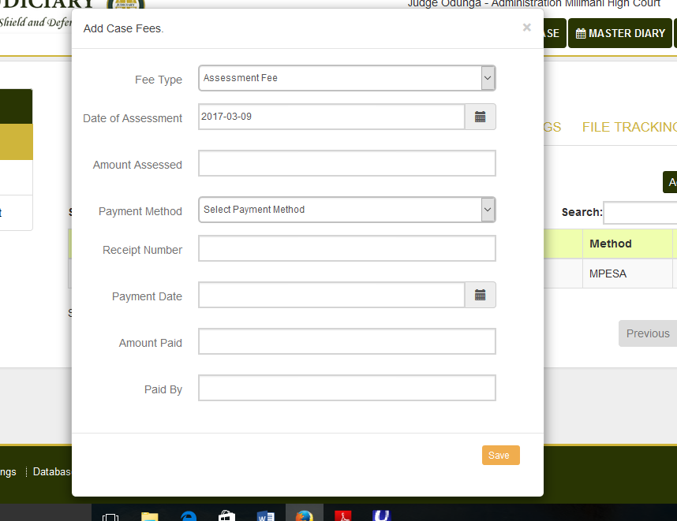

# Reporting portal

This module produces the reports enlisted below

**Attributes of Reporting Portal**

**Reporting**

Case Load

Ad Hoc Reports

Records retention and disposal

TBA

Pending Cases

DCRT

CauseList

# Reports Portal Module Screenshot

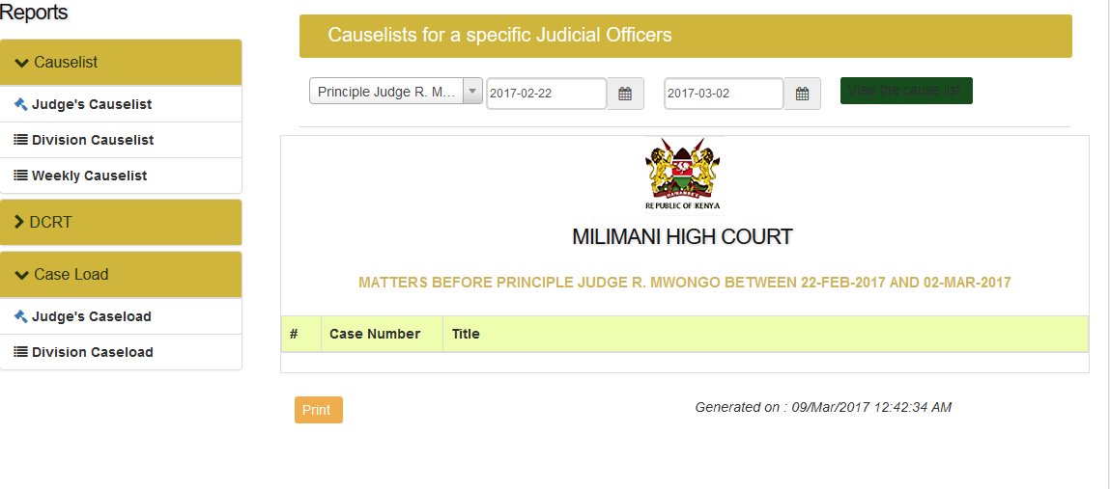



# Database Schema Design

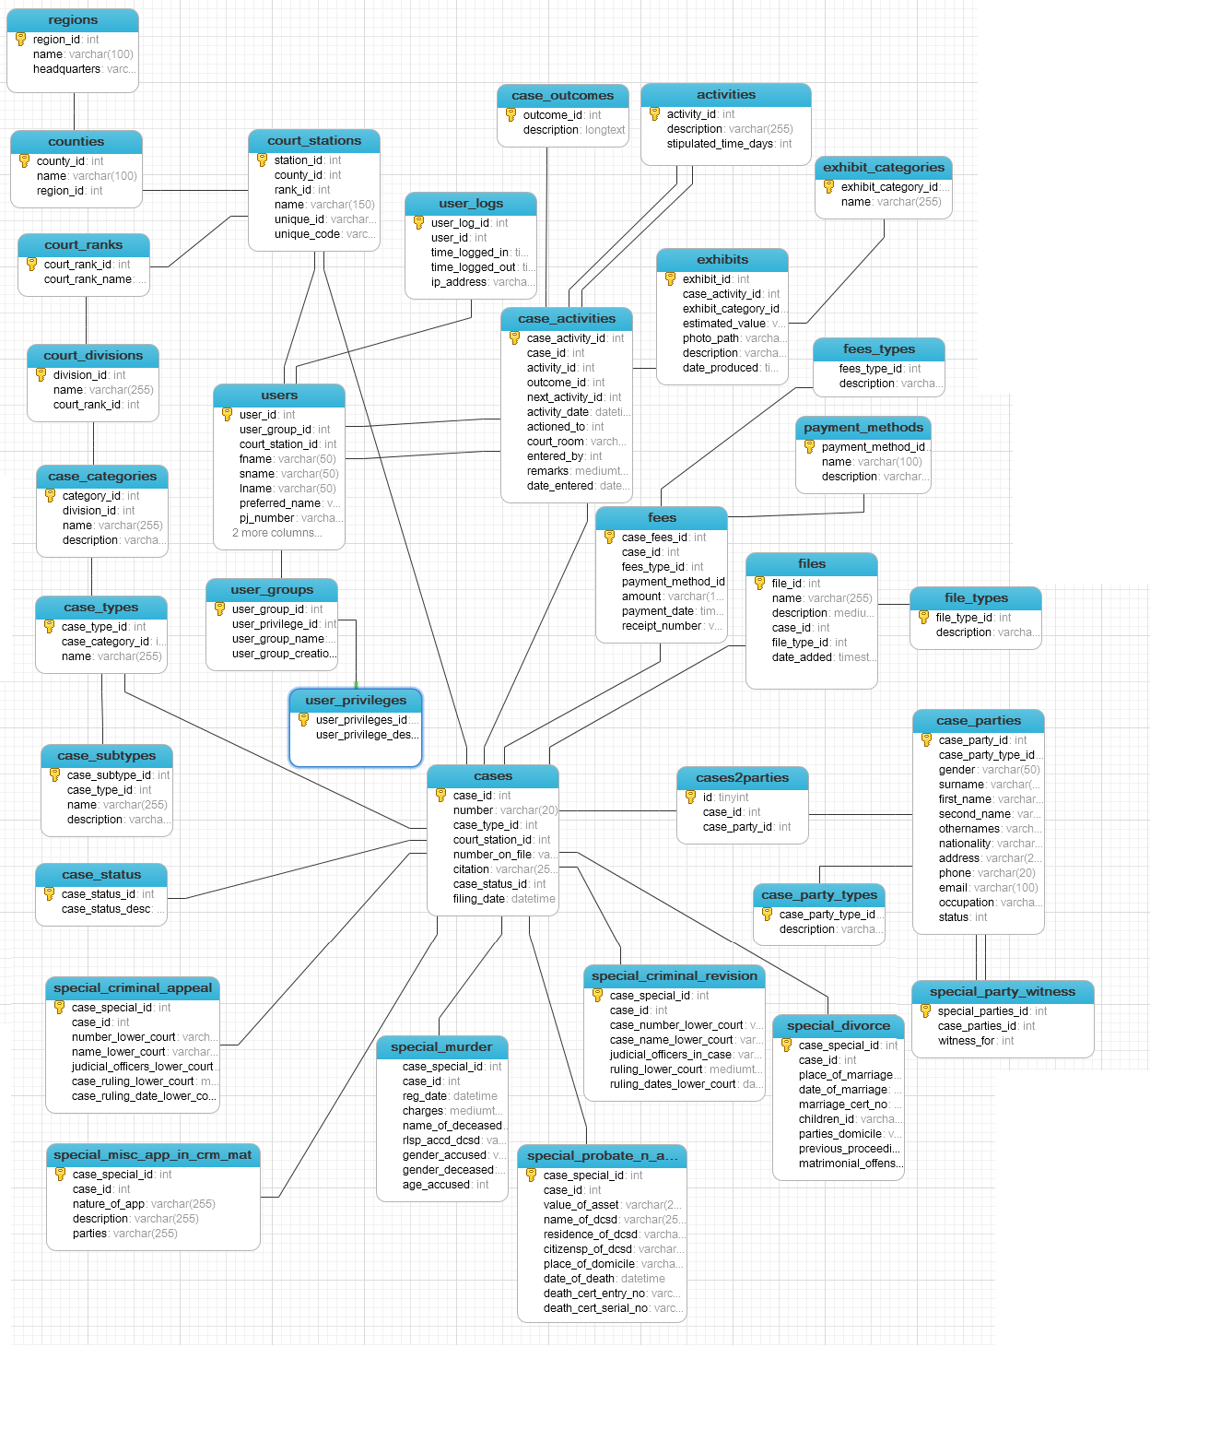

# **Technical Team**

|  |  |  |
| --- | --- | --- |
| **No.** | **Name** | **roles** |
| 1. | Steven Ikileng | Director ICT |
| 2. | Sam Warui | Systems Analyst |
| 3. | Hellen Kabira | Developer |
| 4. | Chelule Maina | Developer |
| 5 | Ernest Omolo | Developer |
| 6. | Benson Macharia | Database Admin |
| 7. | Ivy Minaywa | Developer |
| 8 | Getrude Asango | ICTO |
| 9 | Patrick Ngobiro | ORHC |
| 10 | Geoffrey Atuya | Systems Analyst- Team Lead |

# ANNEXURES: COURT CASE PROCESS WORK FLOW







































